
Summer I 2004: M&IS 24053: Computer Applications
Dr. Jay Weinroth
jweinrot@bsa3.kent.edu
College of Business A421; Office Hours:
Monday thru Thursday, 10:45-11:45 AM
330 672-1150
Section 010
Monday thru Thursday, 2:15-4:10 PM
BSA 217
INFRASTRUCTURE INFORMATION  1. Registration. You must be officially registered and paid up for tuition on the registrar's records to receive a grade for any course on your transcript. Students who are not duly registered in any course by the registrar's deadline will be automatically deregistered and will not receive an official grade until the problem is corrected. For any questions, see the Undergraduate Programs Office in BSA 107. June 16 is last day to avoid late penalties for tuition payment.  2. Last day to withdraw from an individual course in Summer I 2004 without penalty is July 6. | 3. Disabilities. Any student with a disability as recognized by the university office of Student Disability Services is entitled to have special needs provided for. Please notify me immediately if this applies.  4. Grade grievance. If you believe that you have been graded unfairly in any course, there is an official university policy with specific procedures to be followed. The first step is always to talk with your instructor about the problem. Otherwise the various university officials will send you back to follow this first step. Note that the office of the University Ombudsman, Greg Jarvie, provides advice for you in these matters.

Syllabus Contents
- 1. Theme
- 2. Objectives
- 3. Textbook and Materials
- 4. Orion
- 5. Homework
- 6. Quizzes
- 7. Prerequisites
- 8. Extra Credit
- 9. Gift Catalog
- 10. Your Grade
- 11. Daily Class Schedule and Reading Assignments
- 12. Tutors and Proctors
- 13. Rules
- 14. Etc.
- 15. Syllabus Contract

1. Course Theme

Solving information related problems using computers, networks, software and data.

2. Course Objectives

The fundamental objective is for you to develop an appreciation for the contribution that computers and software can make to your life as a student and as a professional. It is expected that during this term you will develop competency in the operation of the hardware and software to which you are exposed. It is further expected that as you master the course material your confidence in your ability will increase. A secondary objective is for this to be an enjoyable and fun learning experience.

3. Textbook and Other Materials
The course's text book is Computers and Information Systems, Steinberg, Geoffrey, Paperclip Productions © 2004
Most of the text's material will be covered. Use the course's weekly schedule as a guide so that you read the appropriate chapters before that material is covered in class. You should read the material before coming to class so that you are ready to participate in the class discussion.

Class Slide Presentations
Copies of the instructor's classroom slide presentations are included with the textbook. You will find these copies very handy when you take class notes. The textbook has exact images of many of the slides used by the instructor. Take your notes directly on the copies. It will make note taking easier and more accurate. You will find it easier to study for quizzes too.

Class Notes
The textbook provides pages for your class note taking. You are encouraged to use these pages so that your notes, the text material and the classroom slides are kept together. This too will help you master the material and prepare for quizzes.

Floppy Disk
You should use the floppy disk which is packaged with the book. Although not required, you may wish to purchase a 3.5" floppy disk to use for backing up your homework.

4. Orion
Many of your course activities are interactive and involve using the Orion server. Quizzes and homework are administered and graded by Orion.

Follow these steps to log on to Orion:
- 1. Start a web browser. You must use Internet Explorer. (Some ORION functions do not operate in Netscape due to security considerations.)
- 2. Go to this web address: http://orion.kent.edu
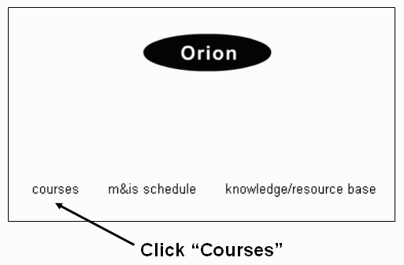
- 3. Select this option:
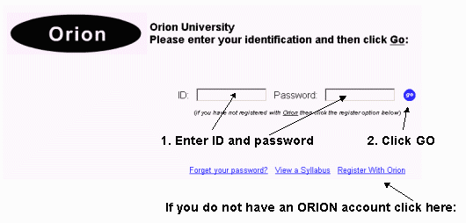
- 4. Enter your log on information:

5. Homework
There are 12 regular assignments. Each assignment is worth one point toward your total semester grade. To view specifics about assignments use your ID and password to log on to Orion and use the option shown below:
All regular assignments are graded automatically by the Orion System. Each regular assignment must be completed by the due date. You may submit any regular assignment three times until the due date. The grade recorded is what you earn on your last attempt (which may or may not be your highest score). The grade on record at the due date is your grade. The "Requirements" option also shows the due dates for each assignment.

Submitting Regular Assignments
You will complete most of your regular assignments using a disk such as the one included with the text. To submit regular assignments use the "Requirements" option from your personal Orion System menu (see above).
Some of your assignments will be graded by an Excel document orion.xls. Some common questions about orion.xls are answered here.

Grade Status
Each time a regular assignment is graded a fresh copy of your grade status report will be put on the Internet for you to access. See this menu for access to status report.

Asking for Help
If you need assistance please ask the instructor. There is no value in holding back. If you ask for help do so before the due date for an assignment. The instructor will not answer email (or phone calls) about the homework on the due date.

Prerequisites
Several homework assignments require that you successfully complete practice exercises first. You may attempt the exercises as often as you wish until you accomplish the required grade of 100. The specific assignments requiring practice exercises are:
Homework 5 requires a grade of:
100 in Excel Exercises 01

Homework 6 requires a grade of:
100 in Excel Exercises 01
100 in Excel Exercises 02
100 in Excel Exercises 03

Homework 8 requires a grade of:
100 in Excel Exercises 01
100 in Excel Exercises 04
100 in Excel Exercises 05

Homework 10 requires a grade of:
100 in Excel Exercises 01
100 in Excel Exercises 06

6. Quizzes
- • There are 8 short objective quizzes (multiple choice, true-false, fill in the blank) through the semester. The schedule shows the due dates. The Requirements option (available from your Orion menu - see illustration below) gives you access to the quizzes.
- • Each quiz score is computed as a percent correct. (a perfect score is 100% )
- • Each quiz is worth 11 points toward your total semester grade. If you score 100% on a quiz then you earn all 11 points. If you score less than 100% the points earned are adjusted accordingly.
- • Quizzes are not curved.
- • Each quiz is administered during a "quiz period". The time window for each quiz is shown in the calendar of assignments. In a Five Week section of this course the time window for each quiz will vary from 2 to 5 days. Remember that you can only take a quiz on a day when the lab is open. Consult the schedule carefully for each of the 8 quizzes.
- • Each quiz is a self-contained unit. That means that the quizzes are not comprehensive. Each quiz contains material covered in class during the two weeks prior to the beginning of the quiz period (the first Quiz is an exception - it covers just one week).
- • There is no final exam. The 8th quiz is also non-comprehensize and is taken during the last two days of class.
- • Quizzes are open notes and you are permitted to use other software while taking a quiz. You are not permitted to discuss anything with anyone while taking a quiz - violations are grounds for receiving a grade of 0 for the quiz in progress.

Taking a Quiz
You may not begin any quiz until you demonstrate your understanding of the syllabus. You must do this by completing the Syllabus Contract.
Once you have successfully completed the Syllabus Contract you begin a quiz this way:
- 1. Bring your student ID to the College of Business Computer Lab (2nd floor) during the quiz period. Any instructor familiar with the format of 24053 is authorized to require you to produce your student ID if you are taking a quiz. Normally we use proctors but these are not available in the summer. Anyone caught cheating on a quiz will receive a grade of F in the course.
- 2. If the sysytem is working correctly, no quiz may be started less than 60 minutes before the closing time for the lab. Do not start a quiz if there is less than 60 minutes before closing time, even if Orion permits you do do so. At closing time you will be logged off with a possibly incomplete quiz and a low score.
- 3. Log on to Orion and select the "Requirements" option (see above).
- 4. Select the quiz you want to take.

Study Tools
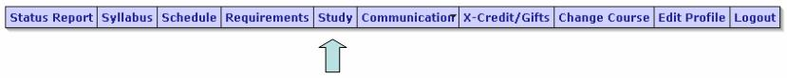
Study tools are available for each quiz. To view a study guide or try a practice quiz: Log on to Orion and select the "Study" option:

Viewing Results
Once a quiz period has ended you may view your quiz (all questions and answers) by locating the quiz in your status report.

Instructor Review of Your Quiz
For this 5 week section, you may request that your instructor review a quiz up to two days after the end of the quiz period. Quizzes will not be examined after the two days have elapsed.

Prerequisites
Several quizzes require that you successfully complete practice exercises first. You may attempt the exercises as often as you wish until you accomplish the required grade of 100. The specific quizzes requiring practice exercises are:
Quiz 3 requires a grade of at least:
100 in Excel Exercises 02
100 in Excel Exercises 03

Quiz 5 requires a grade of at least:
100 in Excel Exercises 04
100 in Excel Exercises 05

Quiz 7 requires a grade of at least:
100 in Excel Exercises 06
100 in Excel Exercises 07

7. Prerequisites
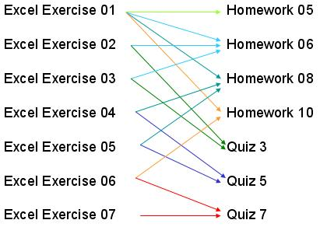
Several homework assignments and quizzes require that you successfully complete practice exercises first. You may attempt the exercises as often as you wish until you accomplish the required grade of 100. This chart summarizes the requirements:
You do not receive credit for the exercises but you must complete the exercises to obtain permission to begin homework assignments and quizzes as shown.

8. Extra Credit
You may earn up to eight extra-credit points during the course. Seven points can be earned by answering extra credit questions (more about this below) and one point can be earned by answering two surveys.

How To Earn Extra Credit
- 1. Random Questions - Up to Seven Points
At various times when logged on to Orion you will be given the opportunity to answer questions about course content. The questions will most likely appear when you are not expecting them. You may be surprised when the questions appear. Each question that you successfully answer will result in an award of some extra credit points. During the course you may earn up to seven extra credit points this way.
The random extra credit questions are all objective (multiple choice, true-false, fill in the blank). Each question has a time limit and you will learn immediately whether or not you received the credit.
Everyone will get the same number of out of class opportunities. There will be additional opportunities available to those who attend class.
Tip: attending class and completing reading assignments on time will help you earn extra credit points.
- 2. Surveys - Up to One Point
During the course two surveys are administered. Completion of each survey is worth 0.5 extra credit points for a total of one point if both surveys are completed.

Grade Status
As extra credit is earned a fresh copy of your grade status report will be put on the Internet for you to access.

9. Gift Catalog
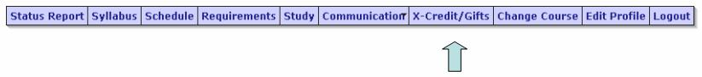

You may purchase gifts from the Gift catalog by using extra credit points that you earned. Click the "X-Credit/Gifts" option to view the Gift Catalog.
Gifts available include:
- • A due date extension
- • An additional homework submission
- • Erase a grade and start over

10. Your Grade

Rules
- • You semester grade is the weighted average of the 8 quizzes + 12 homework assignments.
- • Each quiz and homework is to be completed on time by the due date. You receive no credit for quizzes or homeworks incomplete after the due date.
- • Up to eight points of extra credit may be added to your quiz and homework average.
- • The Kent State grading scale is used:

From | To | Grade is
90 | 100 | A
80 | 89 | B
70 | 79 | C
60 | 69 | D
0 | 59 | F

Grades are rounded, so 89.5 becomes an A.

Grading Example
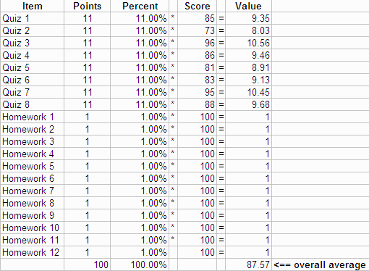
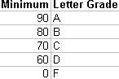
Your grade is based on eight quizzes (worth 11 points each) and 12 homeworks (worth one point each) and eight extra credit points possible.
Here is an example of 8 quiz grades and 12 homework grades:
87.57 points would be a B grade. This grading scale is used:

How extra credit works
If this student earned 2 extra credit points then a total of 89.57 points (87.57 + 2) was earned. The letter grade becomes A because grades are rounded (89.57 rounded to 90).

Important Notes:
- • Grades are rounded (see above).
- • Nothing is curved: not homework assignments, not quizzes and not the semester final grades.

11. Daily Class Schedule and Reading Assignments
The daily schedule indicates the topics covered during each class session. You are expected to complete the reading assignments (pages shown in ()) prior to each class meeting. The Quiz column indicates what quiz covers the material shown to the left.

Week | Day | Date | Assignment | Quiz
1 | M | 6/14 | Introduction  data & info (1.1-1.17&2.1-2.11) | #1  6/15-6/17
 | T | 6/15 | data & info (1.1-1.17&2.1-2.11);  windows (3.1-3.22)->QUIZ 2 | #2  6/17-6/22
 | W | 6/16 | windows & word (4.1-4.9);  Hardware (5.1-5.6)
 | H | 6/17 | Hardware (5.1-5.6);  Software(5.7-5.12)
2 | M | 6/21 | Excel (6.1-6.15);  Excel (6.20-6.25 & 6.29-6.42) | #3  6/23-6/28
 | T | 6/22 | Excel (6.20-6.25 & 6.29-6.42)
 | W | 6/23 | info sys (7.1-7.8);  e-mail/comm(8.21-8.23&8.1-8.21) --à QUIZ 4 | #4  6/28-7/3
 | H | 6/24 | e-mail/comm(8.21-8.23&8.1-8.21)
3 | M | 6/28 | graphics/PP (9.1-9.16)
 | T | 6/29 | Power Point;  Excel--cell address (6.47-6.60)  ---------------à QUIZ 5 | #5  7/1-7/6
 | W | 6/30 | Excel logic (6.664-6.73);  linking sheets (6.78)
 | H | 7/1 | linking sheets (6.78);  internet/html (10.1-10.9&11.1-11.13) ----àQUIZ 6 | #6  7/7-7/12
4 | M | 7/5 | JULY 4 HOLIDAY-NO CLASS
 | T | 7/6 | Html;  societal issues (12.1-12.87)
 | W | 7/7 | societal issues (12.1-12.87);  systems analysis (13.1-13.12)
 |  |  | WARNING – YOU CAN ONLY FINISH QUIZZES 7 & 8 ON DAYS WHEN LAB IS OPEN
 | H | 7/8 | excel merging tables(6.79-6.83);  excel between records(6.83-6.85) | #7  7/13-7/17
5 | M | 7/12 | excel between records(6.83-6.85);  excel charts (6.89-6.94)
 | T | 7/13 | excel charts (6.89-6.94);  database (14.1-14.9)àQUIZ 8 | #8  7/13-7/17
 | W | 7/14 | database (14.1-14.9)  database (14.32-14.35)
 | H | 7/15 | database (14.18-14.28&14.10-14.13)

12. Rules
In order to be fair to all students the following rules are enforced:
- 1. Review of a Quiz Grade

You may ask the instructor to review any specific questions on any quiz or homework assignment. You must make the request not more than two days after the quiz or assignment due date has passed. Requests after that deadline will be automatically rejected.
- 2. Computer Virus

WARNING!!! If you submit an assignment with a computer virus then you fail the course. No exceptions! It is your responsibility to ensure that your work is clean.
- 3. Excused lateness

The following are the Kent State accepted excuses for late homework submission or permission to take a quiz late. No other excuses are accepted:
- • sickness with medical note
- • athletic event - with coach's note
- • religious observation
- • military responsibility with documentation
- • death in family with documentation

No other excuses for lateness are accepted. If you miss a homework or quiz due date then you may purchase an extension from the gift catalog if you wish to complete that assignment. Here are some excuses that are invalid and will be ignored:
- • your Mom will call me to let me know why
- • your alarm didn't go off
- • your kids were sick
- • your parents needed your help
- • you had to work
- • you forgot the due date
- • you check your email, but you don't check Orion
- • you HAVE to get a good grade in here
- • your computer died
- • you cannot access Orion
- • your diskette will not work
- • there was no lab assistant to proctor
- • the lab was in use by a class, etc.
- • your car quit
- • you had an accident
- • any new excuse we haven't heard which you come up with as your contribution to next semester's syllabus
- 4. Lecture

You are expected to respect the other students! This means never ridicule anyone for asking a question. There is no such thing as a stupid question but it is stupid not to ask questions! Laughing at or ridiculing another student is grounds for dismissal from this course with a grade of F.
- 5. Cheating

Cheating is grounds for automatic failure in the course so don't do it! Cheating includes, but is not limited to, copying from another student during an exam, submitting the same homework as another student, and illegally copying (really stealing) software. Any voliation is grounds for dismisal from this course with a grade of F.
- 6. Respect

You are expected to act in a proper fashion at all times during the semester. Being respectful of other students and the instructor is essential. Behaving otherwise will not be tolerated and is grounds for dismissal from the course at any time during the semester. Dismissal results in a grade of F.
- 7. Cell Phones and Pagers

Use of a cell phone or pager during class is grounds for removal from the class. Use of such equipment is rude and disrespectful towarde the instructor and other students (see respect above). Use of a cell phone or pager during class is grounds for dismissal from this course with a grade of F.

14. Etc.

- 1. Attendance

Attendance is not mandatory but it is strongly recommended. You are responsible for all material presented. It is not reasonable for you to ask for special consideration claiming that you miss material because you were not in class.
- 2. Students with Disabilities

In accordance with University policy, if you have a documented disability and require accomodations to obtain equal access in this course, please contact the instructor at the beginning of the semester or when given an assignment for which accomodation is required. Students with disabilities must verify their eligibility through the Office of Student Disability Services (SDS) in the Michael Schwartz Services Center (672-2972).
- 3. Thinking About a Major or Minor in IS?

Enrollment in the initial courses (24060 - Systems Analysis and 24070 Principles of System Development) requires permission. Click here for details.
- 4. e-mail

You are encouraged to communicate with your instructor using e-mail. There are some rules, however, that you must observe to use e-mail effectively:
  - 1. Make sure that your spelling and grammar are correct.
  - 2. Get to the point. Do not be long-winded. No jumbled verbiage.
  - 3. Be organized. Be clear.
  - 4. Be honest.
  - 5. Use proper English - no slang.
  - 6. DO NOT TYPE IN ALL CAPS!
  - 7. Be respectful.
  - 8. Say who you are.

Little tolerance is granted for email messages that violate these guidelines. In fact, if your e-mail is unacceptable you may receive no response!

15. Syllabus Contract
This syllabus is a contract between you and the instructor. Your responsibilities are described in this document. Before you are permitted to attempt any of the course quizzes you must demonstrate that you understand the contract (syllabus) by earning a perfect scrore (100%) on a syllabus survey. Check the course schedule for the survey dates.
You are permitted to attempt the Syllabus Contract Survey as often as you like until you reach 100%. You may attempt the Survey from any Internet connected computer using Internet Explorer. It is strongly suggested that you print this syllabus (use the Print All option) and use it while completing the survey. To find the Syllabus Contract select the Orion menu option indicated below:

